*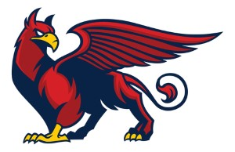****“Feather of flight, courage of heart.”***

April 2019

**Club Voice…** Spring has sprung, clocks have changed an hour forward, evenings are getting lighter and the weather is improving (fingers crossed). Outdoor season is upon us and so we get to try longer distances and alternative rounds.



Griffin Archers, for those who have somehow missed it, Di has gone a bit mad with the illustrations on this newsletter, to help highlight our name change. I suppose it shows the diverse variety of images that a mythical

creature with the head and wings of an Eagle and the body and legs of a Lion can conjure up.



So now as “Griffins” we are strong, loyal, lionhearted. We remain true to our ethos, being inclusive, diverse and for the good of the membership!

Anyway, back to the Archery, lets get our shooting, scoring and enjoyment levels up. I know that on the occasions I shoot it helps relieve stress and focus my mind. As a veteran archer and as a coach I understand that Archery is as much a mental attitude as physical technique. I see many of you fighting to achieve better shooting, better scores. Sometimes its your self that blocks the natural flow of your archery. Muscle memory and consistency achieve as much as positive mental attitudes. I just wanted to remind everyone that myself, Di and most members are all around to help, encourage or just have a cuppa and a chat.

Keep shooting! ***John***

***John***



Newsletter

**Dates for the Calendar**

**Club Night - Fridays 7pm – 9pm**

**Taster Sessions – 1st Friday of Month – 6;30pm – 7pm**

**5th April, 3rd May, 7th June.**

**End of Month shoots April 26th, May 31st and June 28th.**

**Watch out for details of extra shooting sessions,**

**along with have-a-go fund raising and**

**competition opportunities.**

***Griffin Archers*** 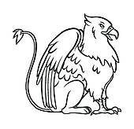

***The new name for Invictus Bowmen. Nothing else changes, just the name!***

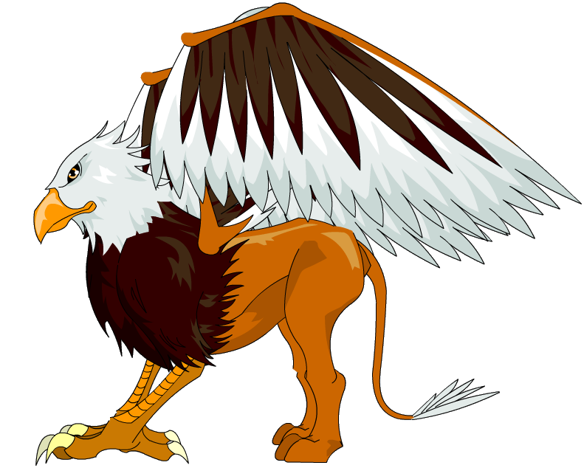

#### Sun block, rain coats

#### And folding chairs.

#### Blankets and hot drinks, water

#### and sunglasses. Maybe an extra jumper… JUST OUTDOOR ARCHERY!!!

  **A bit of fun!!!** 

**How many Griffins can you spot? Words and images.**

**Whisper your answer to Di before the end of April 2019 and win a small prize.**

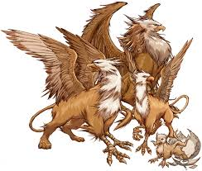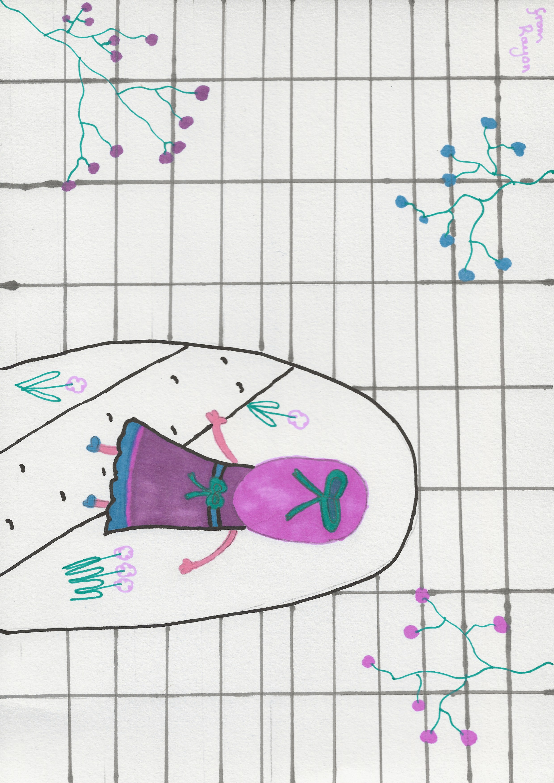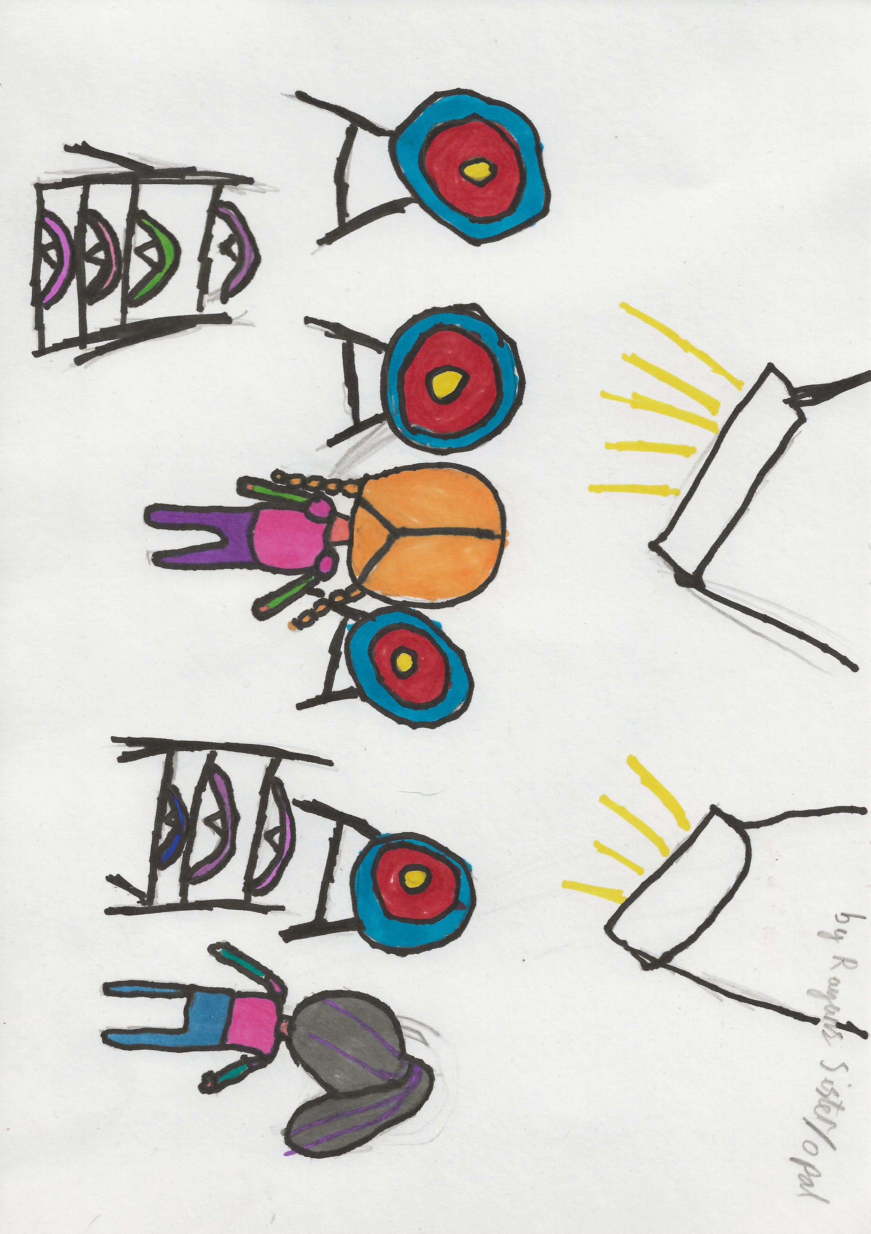

We have a talented bunch of Juniors and their families. Rayon and her sister Opal created these works of art.

They are too good not to share!

**Maybe some of you will be inspired to draw or create a version of a Griffin!**

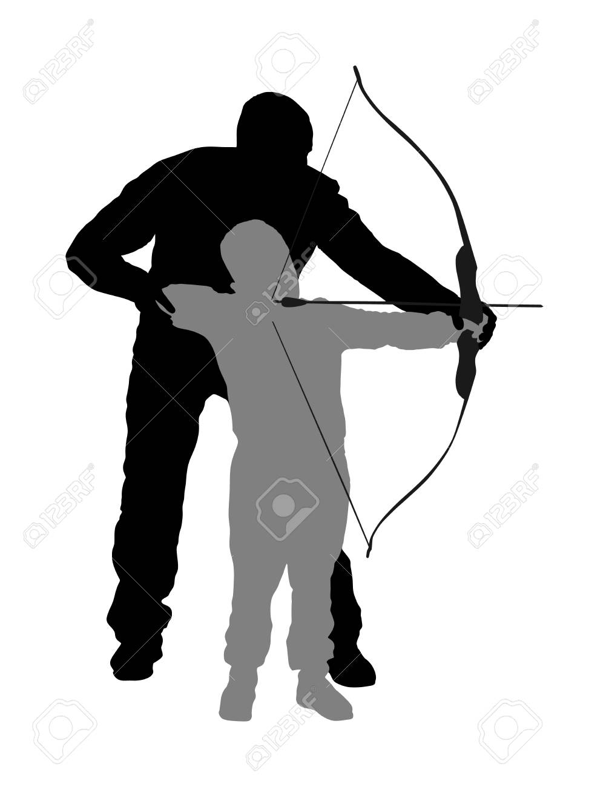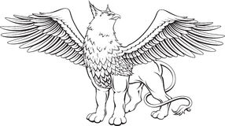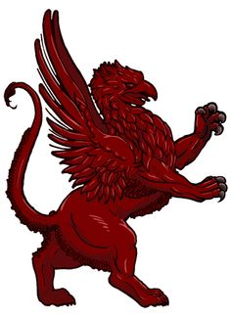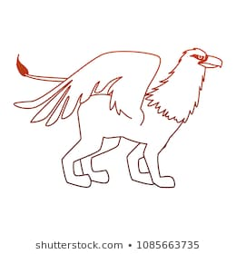

*We are delighted to announce that a new Mascot for our Junior Griffins is on his way! Little Griff is our new mascot, he will have his own reasons for being part of our Griffin Archery family, he has the added jeopardy that he likes to fly away so our juniors will definitely have their hands full! He hasn’t quite been house trained so may help himself from the fridge or fruit bowl.*

Opal fruits are now STARBURST



Marathon is now SNICKERS

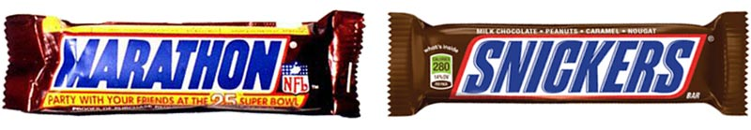

Jif kitchen cleaner is now CIF

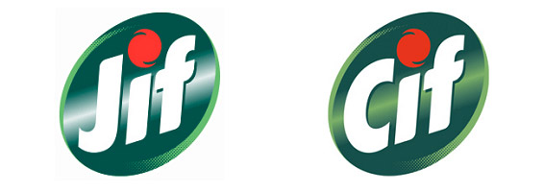

Thomson Holidays is now TUI



Kentucky Fried Chicken is now KFC



**And of course…..**

**Invictus Bowmen are now**

**“Griffin Archers.**

**trivial facts…**

**Little Griff will be taking over from Vic the Phoenix.**

***We are on Social Media,***

***Why not follow us and comment!***

JUNIOR MEMBERS –

So, we have our first Pirates half-Portsmouth League winners.

Male – Thomas Sharpe 1st

Casey Knights 2nd

Female- Cheyanne Ferreday 1st

Rayon Wright 2nd

Best Improver – Daniel Barlow

**GRIFFIN ARCHERS CLUB MOTTO!**

Thomas won a prize his motto is at top of Newsletter. Couldn’t have judged this on the spot chance to be part of club history without mentioning two others;

***“Power of the Griffin tall and small, we stand by its side till night falls”***

Such a beautiful sentiment by Rayon

And finally 

***“Winner, winner Griffin dinner!”*** by Casey

**…and Finally….**

If you want to have one of our used targets for your garden, chat to John and make a donation to club!

 